Press release: Mearraspeajal / Havspeilet (The sea mirror) - New album from Johan Sara jr.

The second album in the trilogy «Mearrasápmelaš» deals with the Sea Sami roots.

In an acoustic and dynamic soundscape, Sara returns to the starting point of his career on the album trilogy «Mearrasápmelaš / Sea sámi», and also like «Ovcci vuomi ovtta veaiggis» album in 95.
The second album "Mearraspeajal" is recorded live in studio, and cultivates the immediate and direct in such a way of working, where the rhythms and melodies can almost be touched and felt - up close and personal, and the joik leads the way through various sonic landscape.

The Sea Sami culture is closely connected to the sea, which has been important for food, traditions, culture, trade, transport and communication. It has been important to create connections between different cultures and groupings such as inland and the coast. The language and music have been, and are, carriers of these cultural values ​​and traditions.

We as humans fundamentally needs to know our heritage - to know where we come from, who we are, where we belong, to feel a sense of belonging and to share it. "Mearraspeajal" looks in to these roots which help to strengthen identity and belonging. Roots that refer to origins, history and traditions that have shaped Sea Sami culture.

"Mearraspeajal" is set in a Sea Sami context, and seeks the original Sea Sami soul and the spirit. It is released on vinyl and streaming, and contains three long works. The trilogy is a larger coherent art project on vinyl of which the cover design is also a part.
Johan Sara jr. is a joiker, composer, musician and visual artist and has a Sea Sami background and was born and raised in Alta and on Stjernøya. He lives in Maze and works there. "Mearraspeajal" is his 19th album release.

This release is based on the 3 instruments we know in Sami music; voice, flute and drums.

With him Johan Sara jr. two outstanding musicians: Erik Håkon Halvorsen on keys, and Stein Inge Brækhus on drums and percussion. Together they have worked out a close and listening interplay, based on improvisation and created a form that leads listeners through different landscapes where the joik and poetry are guides.

Guest musician on various flutes from Turkey is Serdar Kastelli
Producer, art work, cover design on the album is Johan Sara jr.

The publication is supported by the Sami Parliament in Norway.
Contact: Johan Sara jr., tel. (+47) 976 18383. Email: johansara@gmail.com

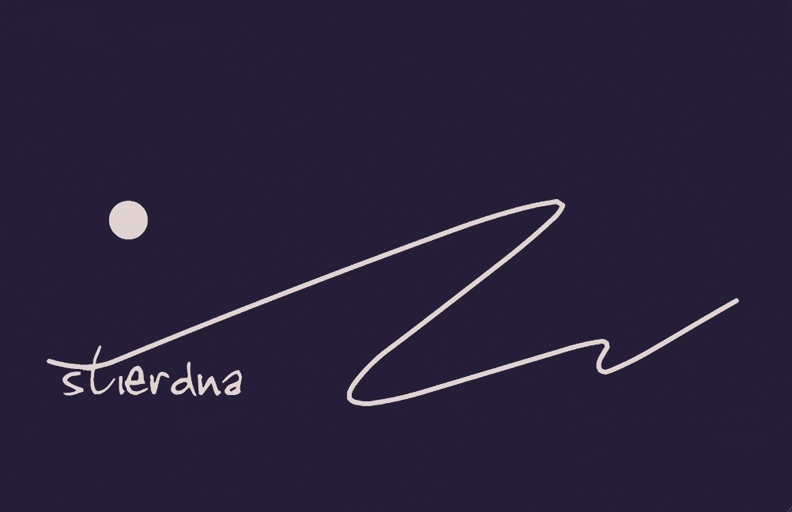
STI20 CD All rights reserved © & P 2023 STIERDNA, pb 95,N-9525 Máze www.stierdna.com johansara@gmail.com Stierdna facebook RLabel www.musikkoperatorene.no

